Cobas c111

Operator Knowledge monitoring

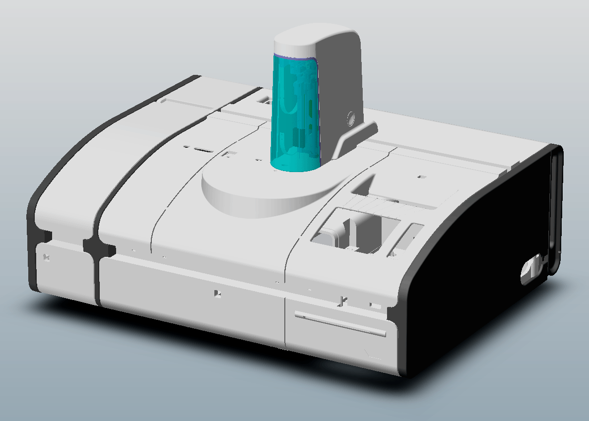

Version 2.0
Name: ___________________________________________ Date: _____________________

About this operator review:

With this operator review you should check yourself, how this training course has helped you and which information we could give you. In addition you have now a short reference with the most important basics.

On the other hand this final review is a good feedback for the trainers on which part of the training course we have to improve or to consolidate, because you should profit optimally from the service training course.

Please answer the following questions:
-  means with a clear cross  or a big point 

If it is not written something else, only one answer for the multiple choice questions is correct.

If it is written, more than 1 answer is correct, you should have all answers correct marked for getting the maximum points of this question. If there is something correct marked, but not everything, you will get the half of the maximum points. If you marked everything wrong, you will get zero points for this question.

Of course you can use all sources, like manuals, eSDoc or own notices for this final review but excluding your neighbors.

If it is not explicit written, all questions are referring to the cobas c 111.

If you don’t understand a question, please do not hesitate to ask the trainer.

The result of this final review will not be communicated to your country organization. It should be helpful for you and also for us trainers to see where still gaps in the knowledge are.

You will get later on the whole final review including the correct answers.

Please don’t forget to fill out the top of this page.

Your Score: ____ / 44__ Points

Group Average: _________ Points

Reviewer: _____________________________

- 2 Points  What are the two measurement principles of the cobas c111? |  ABS and FP   FP and Nephelometry   ABS and ISE   ISE and FP

- 2 Points  How does the c 111 identify a reagent bottle? |  Type in the bottle number   Scan the bottle barcode   Both of the above

- 2 Points  The reagent disk provides space for how many reagent bottles? |  27   37   25

- 3 Points  How long is an Instrument Measurement Cycle? |  8 sec   10.6 sec   18 sec   24 sec

- 2 Points  When are you allowed to load Cuvettes? |  Instrument in standby mode   Instrument in operating mode   Instrument switched off   All of the above

- 4 Points  How is an immediate Alarm message indicated? |  Beep sound   Orange blinking LED at the Sample Area   Red LED next to the Alarm button   Red LED next to the Status button

- 3 Points  The liquid level in the Waste container is monitored? |  Using a Liquid sensor   Visual by the Operator   Using a floater Switch   Using a inductive Sensor

- 2 Points  How many different wavelengths does the ABS photometer use? |  1   2   12   8

- 2 Points  How are the sample tubes detected? |  Flag in a light barrier   Reflection light barrier dtects tube   No HW-Detection, only monitored by SW

- 2 Points  How does the c 111 identify the sample tube type? |  Configuration data   By scanning the sample tube   it is not necessay to identify the tube type as it uses a Tube Bottom Sensor

- 2 Points  How does the c 111 keep track of the reagent bottle filling level? |  Database counter only   Liquid Level Detection only   Both Counter and Level Detection

- 2 Points  What is the reaction temperature inside the Cuvette? |  37°C   140°C   8°C

- 2 Points  At what temperature are the reagents kept inside the instrument? |  8°C +- 2°C   12°C +- 1°C   20°C +- 0.1°C

- 2 Points  What do you have to do in the Prepare wizard step by step? |  load database, check bottle, load reagent disk select due calibration, place calibrator, load reagent, check Cuvettes,   check bottle, check due Service action, load reagent disk, load reagent, check Cuvettes, select due calibration, place calibrator   load reagent disk, check Cuvettes, load reagent, check bottles, select due calibrations, load reagent, load calibrator

- 2 Points  What is the meaning if a reagent is colored yellow? |  Ready for use   No test can be performed with this reagent set   The number of available test is 0   The expiration date of the set has expired or there are less than 10% of the tests left for this set

- 2 Points  How is a sample identified? |  Reading barcode if available   key in sample identification manually   Both of the above

- 2 Points  When you first start processing orders, which sample will be processed first? |  The first placed order will be processed first then the second, third,…   The leftmost position followed from left to right   the scheduler calculates the best order sequence   The order sequence is casual

- 3 Points  What happens if you press “Abort” during sample processing? |  Finish the current Pipetting action, but do not start a new one.   Stop immediately all processing activities   Shut down the cobas c 111 software and the operating system   Shut down the cobas c 111 software and automatically restart it

- 3 Points  How can you restart the instrument? |  Press Restart (Global Action Key)   Switch off/on the main switch   Both of the above   Shutdown instrument (Global Action Key)

VERSION HISTORY
Version | Date | Modifications
1.0 | August 2006 | First Version

- 3 Points  Question Template |       

